H.T No
Regulations:
A17

Sreenidhi Institute of Science and Technology
(An Autonomous Institution)
Code No: 6W102 Date: 18-June-2019 (FN)

M.Tech I-Year I-Semester External Examination, June - 2019 (Supplementary)
ADVANCED FINITE ELEMENT ANALYSIS (CAD/CAM)

Time: 3 Hours Max.Marks:75

Note: a) No additional answer sheets will be provided.
b) All sub-parts of a question must be answered at one place only, otherwise it will not be valued.
c) Missing data can be assumed suitably.

Part - A Max.Marks:25

Answer all QUESTIONS.

1. | Show the propagation problem finite element formulation and list the methods used for solving it. | [3M]
2. | Develop the transformation matrix used for conversion of space beam element co-ordinates from local to global system. | [3M]
3. | List the assumptions in classical theory of thin plates. | [3M]
4. | Develop the consistent mass matrix for a plane truss element. | [3M]
5. | List the assumptions used in radiation heat transfer finite element problem formulation. | [3M]
6. | Write the governing equation for 1D stream function formulation. | [2M]
7. | Write the stiffness matrix for space frame element. | [2M]
8. | What do you mean by orthogonalization of modes. | [2M]
9. | Write the boundary conditions in fin problems. | [2M]
10. | Write the main features of Choleski method of solving equilibrium problems. | [2M]
Part – B Max.Marks:50
ANSWER ANY FIVE QUESTIONS. EACH QUESTION CARRIES 10 MARKS.

11. |  | Find the Eigen values and eigenvectors of the following matrix using the Power method.  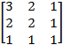 | [10M]
12. |  | A two-dimensional frame is shown in figure. Using three degrees of freedom per node, derive
 | a) | The Global stiffness matrix of order 9x9 before applying the boundary conditions. | [5M]
 | b) | The Global stiffness matrix of order 3 x 3 after applying the boundary conditions.  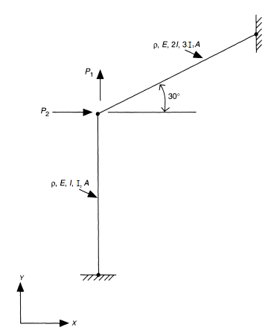 | [5M]
13. |  | Develop the stiffness matrix for triangular plate bending element. | [10M]
14. |  | Determine the natural frequencies of the plane truss shown in figure.  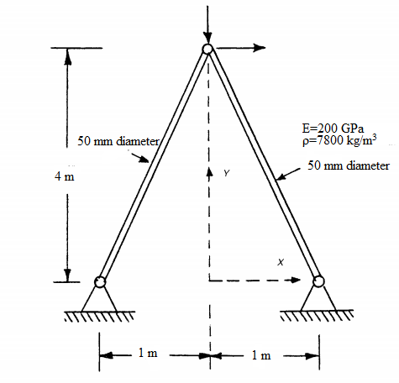 | [10M]
15. |  | Discuss the unsteady state temperature distribution in a plane wall that is insulated on one face and is subjected to a step change in surface temperature on the other face using two elements. | [10M]
16. |  | Discuss the potential function formulation and it’s finite element solution. | [10M]
17. | a) | Find the inverse of the following matrix using the decomposition [A] = [L] [L]^{T} , where [L]=Lower triangular matrix.  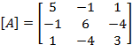 | [4M]
 | b) | Discuss briefly forced vibration response of axial bar | [3M]
 | c) | Transient heat transfer in 1D fin. | [3M]

-- 00 -- 00 –

